***Python Assignment Questions***

1. **File Analysis: Count Words, Lines, and Characters**

**Objective**:

Write a Python script that reads a text file and computes:

1. The total number of lines.
2. The total number of words.
3. The total number of characters.

**Requirements**:

1. Accept the file path as input.
2. Handle cases where the file does not exist gracefully.

Answer:

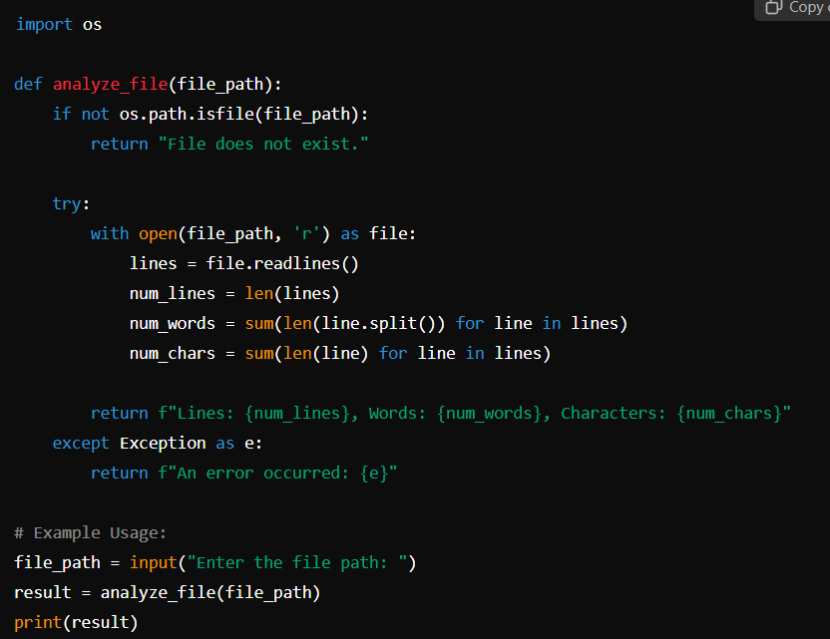

1. **Generate Fibonacci Sequence up to N and Find Primes**

**Objective**:

Write a Python function that:

1. Generates the Fibonacci sequence up to a given number N.
2. Filters and prints only the prime numbers from the sequence.

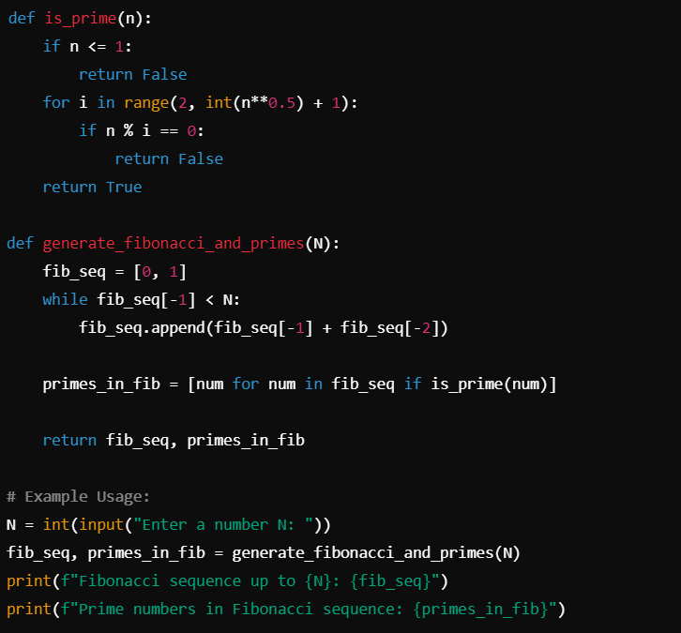

**3. Find the Second Largest Number in a List**  
  
 **Objective**:

Write a Python function that takes a list of integers as input and returns the second largest number in the list.

**Requirements**:

1. Handle cases where the list has duplicates.
2. If the list has fewer than two unique numbers, return None.

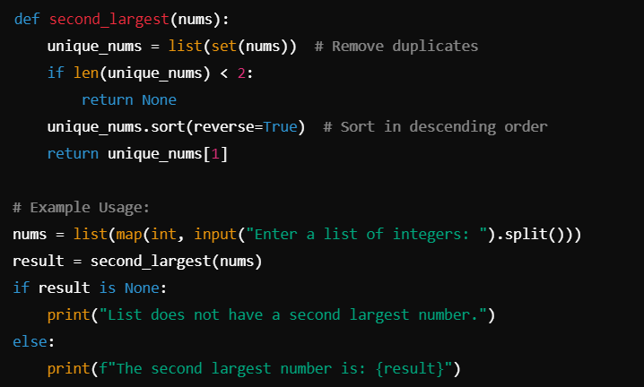

4. **Check If a String is a Valid Anagram**  
  
**Objective**: Write a Python function that checks whether two strings are anagrams of each other.

**Requirements**:

1. Ignore case sensitivity.
2. Consider only alphanumeric characters (ignore spaces and punctuation)

